**Prediction Of Hospital Admission Using Machine Learning**

**Software requirements**

**• Programming Language : Python, Colab**

**• Packages : Numpy,Matplotlib, SKLearn, Pandas,**

**• Tool : Python 3.7**

**Data set description:**

For hospital admission prediction we take patients data. This data consists fifty columns and 101766 records.

**encounter_id, patient_nbr, race,gender, age, weight, admission_type_id, discharge_diposition_id, admission_source_id, time_in_hospital, payer_code, m, edical_specialty, num_lab_procedures, num_procedures, num_medications, number_outpatient, number_emergency, number_inpatient, diag_1, diag_2, diag_3, number_diagnoses, max_glu_serum, A1Cresult, metformin, repaglinide, nateglinide, chlorpropamide, glimepiride, acetohexamide, glipizide, glyburide, tolbutamide, pioglitazone, rosiglitazone, acarbose, acarbose, miglitol, troglitazone, tolazamide, examide, citoglipton, insulin, glyburide-metformin, glipizide-metformin, glimepiride-pioglitazone, metformin-rosiglitazone, metformin-pioglitazone, change, diabetesMed, readmitted**

above all names are dataset column names.

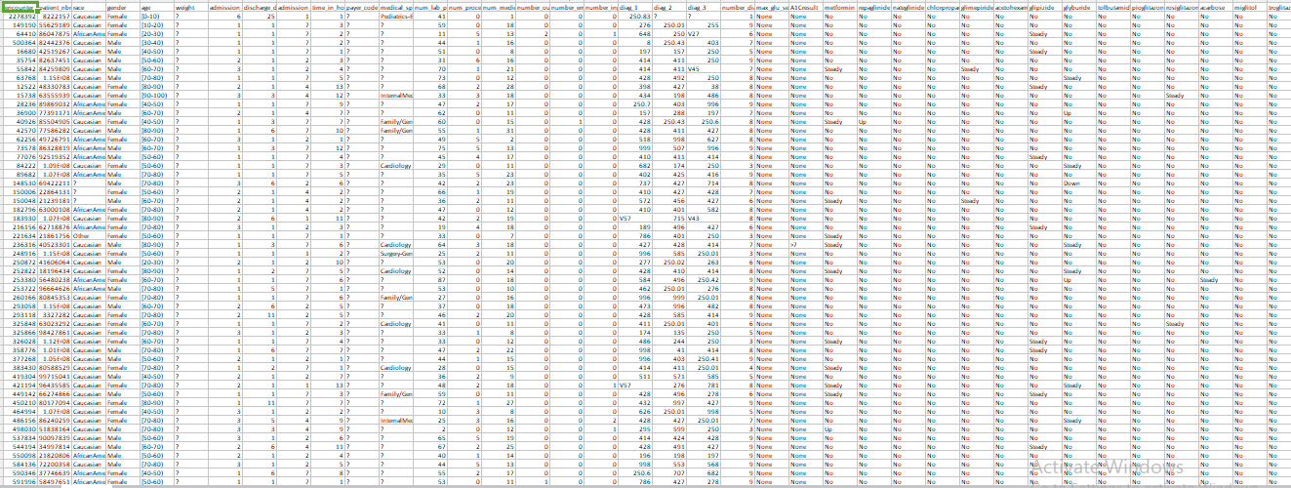

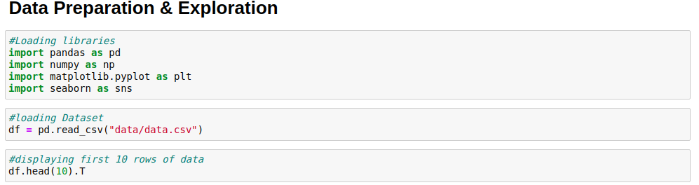

**Data Visualization**

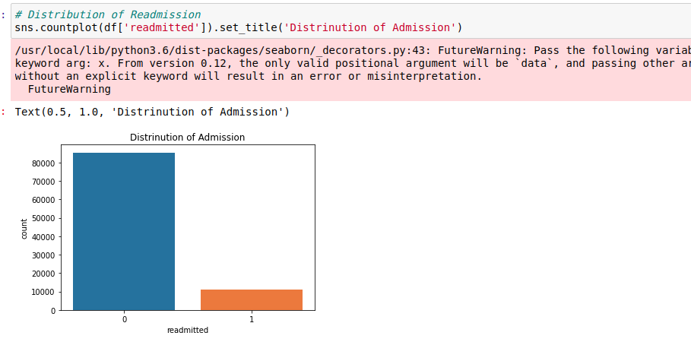

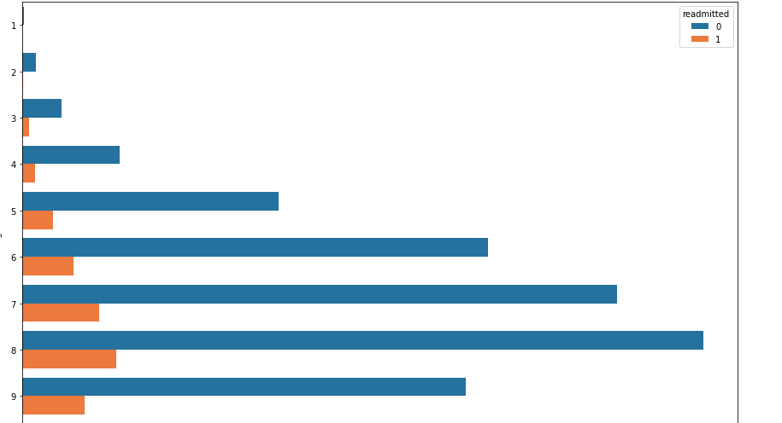

**Based on age and admission**

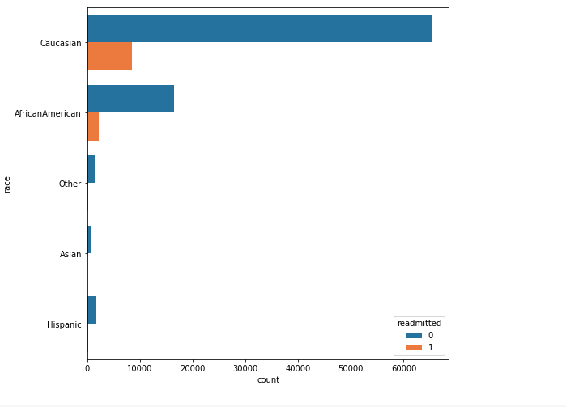

**Based on race and admission**

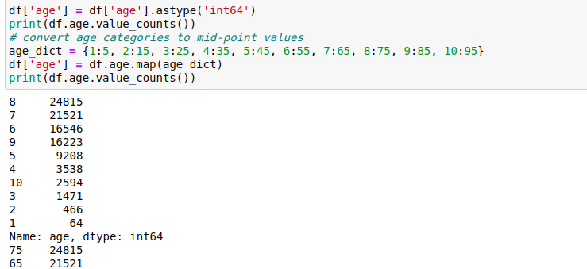

**Modelling and Data preprocessing**

**ML deploying**

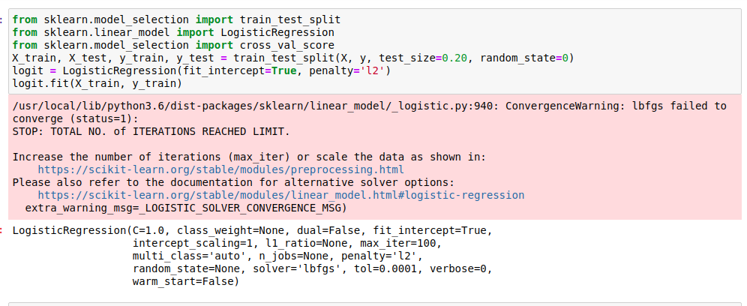

**Prediction based on LR**

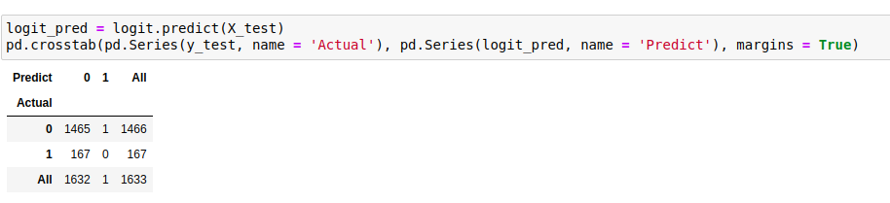

**Prediction based on DT**

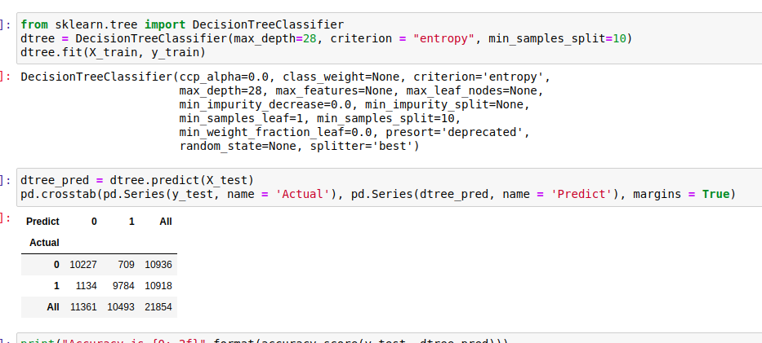

**Prediction based on RF**

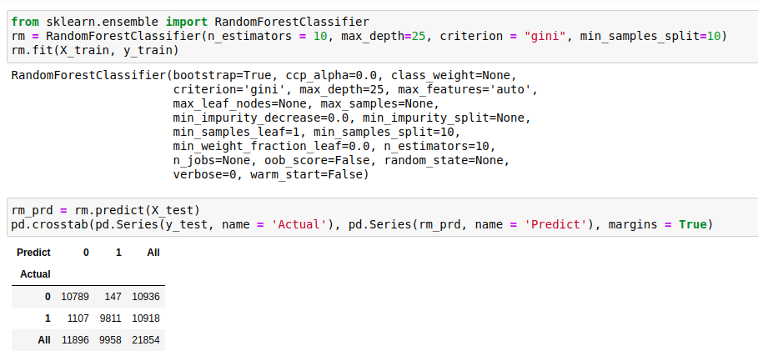

**Prediction based on SVM**

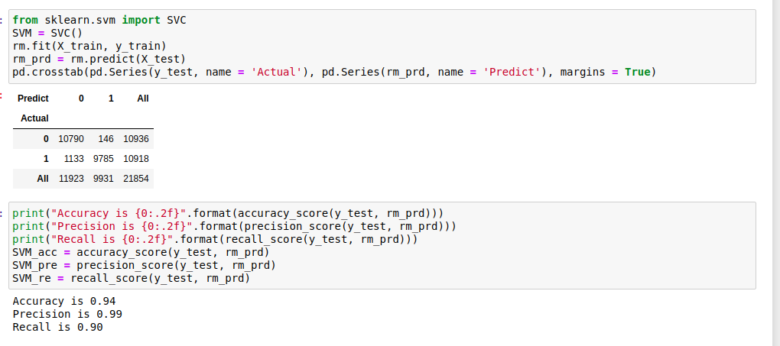

**Model Comparsion**

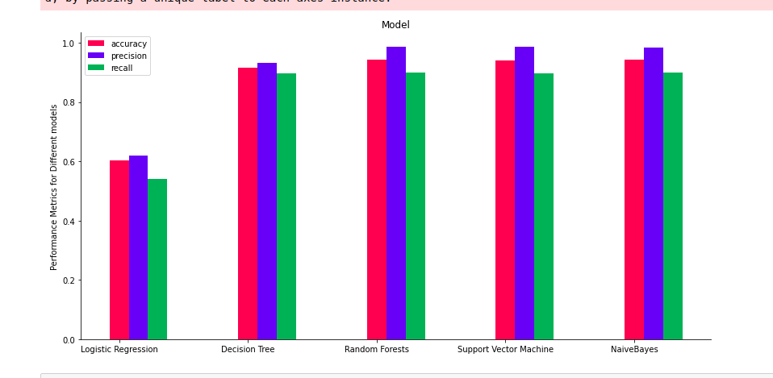

**From the above the RF & SVM are giving better accuracy for prediction**